Likelihood-ratio test

Intro

The liklihood-ratio test tests the goodness of fit of two completing statistical models, based on ratio of their likelyhoods.

Def

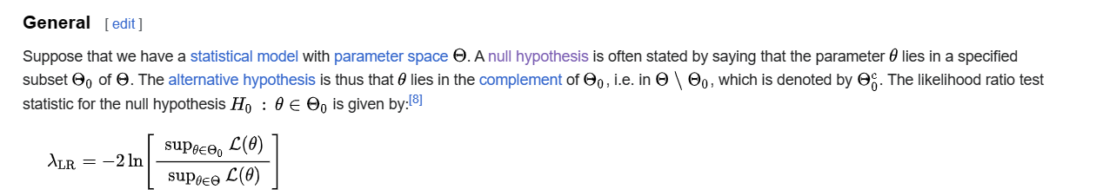

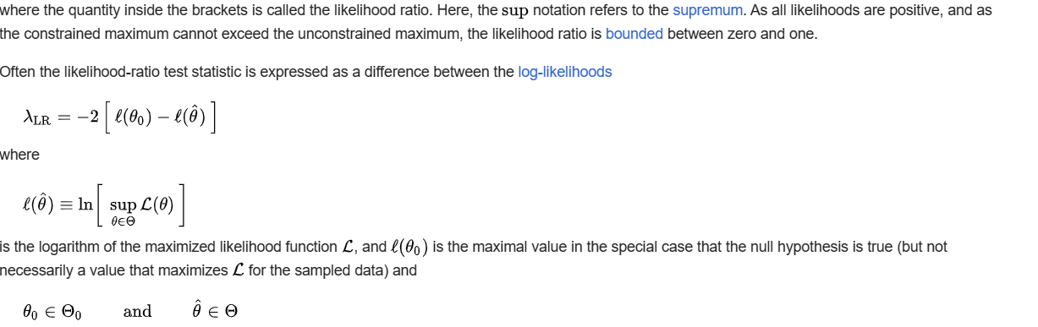

Asymptotic distribution

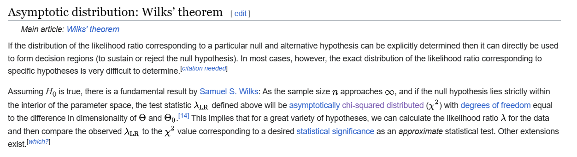

Ref

[Likelihood-ratio test - Wikipedia](https://en.wikipedia.org/wiki/Likelihood-ratio_test)